
.
THE MOST HOLY TRINITY  MAY 27, 2018

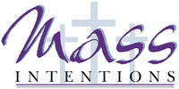
Sat. May 26 VIGIL-THE MOST HOLY TRINITY
4:00pm Winifred Maskarinetz by Michele Miley

Sun. May 27 THE MOST HOLY TRINITY
8:30am Dennis Stetz by M/M Stephen Proch
9:45am For the People of the Parish

Mon. May 28 WEEKDAY EIGHTH WEEK IN ORDINARY TIME
8:30am Communion Service & Novena to Saint Rita

Thurs. May 31 THE VISITATION OF THE BLESSED VIRGIN MARY
8:30am Communion Service & Rosary

Sat. June 2 VIGIL-THE MOST HOLY BODY & BLOOD OF CHRIST
4:00pm For the People of the Parish

Sun. June 3 THE MOST HOLY BODY & BLOOD OF CHRIST
8:30am Vincent Chiodo by Mary Ann Chiodo
9:45am Rita Gartner by Tamara Ivanova

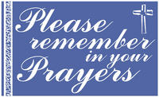
Parishioners who are sick and in need
of prayers can be added to our prayer
list by calling the Parish Office at
570-842-4995. Please pray for:
Tony Perrotti III, Lenny Olechna,
Betsy Kressler, Joseph Ferenczi,
P.J. Cappola, Helen Zerbe, Paula Peet, Carmel Ann Maxson,
Nicholas Pierotti, Susan Golombos, Bob Jantz, Joseph Falchek,
Donna Jean Marabella, Jeanne Tierney, Ben Topar, Pete Tambasco, Arline Chumacas, Jenny Filingo, Jerry White, Jennifer Simis,
Alan Lemech, Vincent Orazi, Phyllis Braun, Richard Major,
Vonette Castelblanco, Bill Vockroth, Jane Colwell, Jeanne Kopyta, Muriel Calame, Jamie Jantz, Donna Lewis, Jason Scott Taylor,
Joanne Arredondo, Vincent Natoli and all the sick of the Parish.

Our Pilgrim Statue of the Blessed Virgin Mary

If she has not yet visited your home and you would like information or to sign up to have the Statue visit your home, please call Pat Manago at 570-848-2284.
This is where the statue will be traveling in the
weeks to come: 5/27-Manago Family 6/03-Manago Family
6/10-Fossetta Family 6/17-OPEN
6/24-OPEN 7/01-OPEN

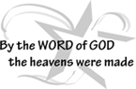



STEWARDSHIP OF TALENT:
May 27, 2018 THE MOST HOLY TRINITY
LECTORS:
May 26^{h} 4:00pm Lyne Van Houtte
May 27th 8::30am Richard Colwell
9:45am Sharon Lenzer
EXTRAORDINARY MINISTERS OF THE EUCHARIST:
May 26th 4:00pm Tony Butel/Mary Rounsavill
May 27th 8:30am Amanda Proch/Veronica Yanulavich
9:45am Daria Killian/Kathy Fossetta
ALTAR SERVERS:
May 26th 4:00pm Alan Hynes
May 27th 8:30am Susan Pilosi
9:45am Ayden Hull
HOSPITALITY & USHERS:
May 26th 4:00pm Andy Kelemen/Victor Benfatti
May 27th 8:30am Ed Snyder/Tom Volpe
9:45am Frank Kopyta/Tom Quinn
June 3, 2018 THE MOST HOLY BODY & BLOOD OF CHRIST
LECTORS:
June 2nd 4:00pm Mary Rounsavill
June 3rd 8::30am Mary Ann Chiodo
9:45am Brielle Ostrowski
EXTRAORDINARY MINISTERS OF THE EUCHARIST:
June 2nd 4:00pm Ron Natoli/Lyne Van Houtte
June 3rd 8:30am Tony Butel/Pat Manago
9:45am Tony Butel/Daria Killian
ALTAR SERVERS:
June 2nd 4:00pm Alan Hynes
June 3rd 8:30am Amanda Proch
9:45am Kathy Fossetta/Jamison Ostrowski
HOSPITALITY & USHERS:
June 2nd 4:00pm Andy Kelemen/Victor Benfatti
June 3rd 8:30am Richard Colwell/Evan Sennefelder
9:45am Tom Quinn/Richard Erazmus

STEWARDSHIP OF TREASURE:


5/20/18
ENVELOPES (69): $ 1422.00
LOOSE: $ 364.00
SUPPLEMENTARY (2): $ 10.00
UTILITIES (36): $ 198.00
ONLINE (1): $ 28.00
TOTAL: $ 2022.00

05/20 05/13 05/06 04/29
PEOPLE ATTENDING: 4:00PM 57 64 56 96
8:30AM 59 61 64 52
9:45AM 41 45 63 83

THANK YOU FOR YOUR CONTINUED SUPPORT!
To meet our weekly obligations, our approximate
weekly income needs to be $2500.00.

VOCATIONS GOLF CLASSIC-JULY 9, 2018
BLUE RIDGE TRAIL GOLF CLUB
Fostering vocation to the priesthood and assisting our seminarians are among the most urgent responsibilities of the faithful in the Church Today. You don’t have to be a golfer to support the 8th Annual Vocations Golf Classic to be held Monday, July 9, 2018 at Blue Ridge Trail Golf Club, Mountain Top, PA. Donors and advertising sponsors are also welcome in any amount. For a brochure or to give by credit card, call the Diocese Development Office at 570-207-2250 or visit www.DioceseofScranton.org (Giving Tab).
Thank You!


SAINT RITA BUS TRIP TO THE SANDS CASINO, BETHLEHEM
WE NEED TO FILL THE BUS!
WHEN: June 13, 2018
Bus leaves Saint Rita at 10:00am and will return at 5:15pm. COST: $25.00 per person, REBATES: $20.00 in slot play and $5.00 in food money. Sponsored by Saint Rita Church. For information and reservations call Mary at 570-676-3711 or the Parish Office at 570-842-4995.


BASKET RAFFLE TO BE HELD FROM MAY 26 THROUGH JUNE 17
The Basket Raffle has begun this weekend and continues till June 17 when we will draw the winners. Stop down and see all the wonderful baskets and gift certificates available to win.

YOUR YEARLY ENVELOPES ARE HERE
We ordered envelopes for all our registered parishioners. Please check the lower level of the Church if you have not yet picked yours up! If you need assistance, please ask one of the ministers for help.

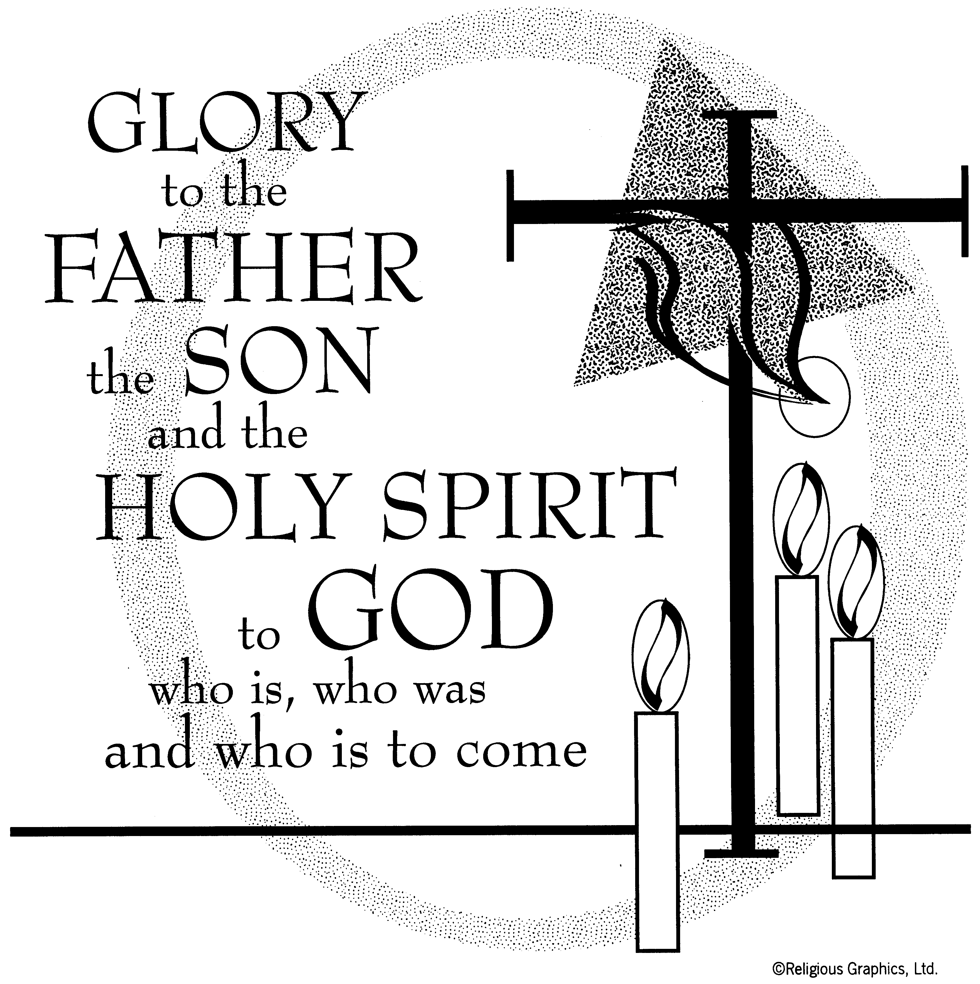

PLEASE JOIN US FOR COFFEE AND
A SNACK FOLLOWING MASS IN THE LOWER LEVEL OF THE CHURCH AS OUR PASTORAL COUNCIL MEMBERS WILL BE HANDING OUT OUR PARISH PASTORAL PLAN FOR THE NEXT 3-5 YEARS.
TAKE IT HOME, READ IT OVER AND SEE IF THERE IS ANY PARTICULAR ACTIVITY OR GROUP YOU WOULD LIKE TO JOIN.

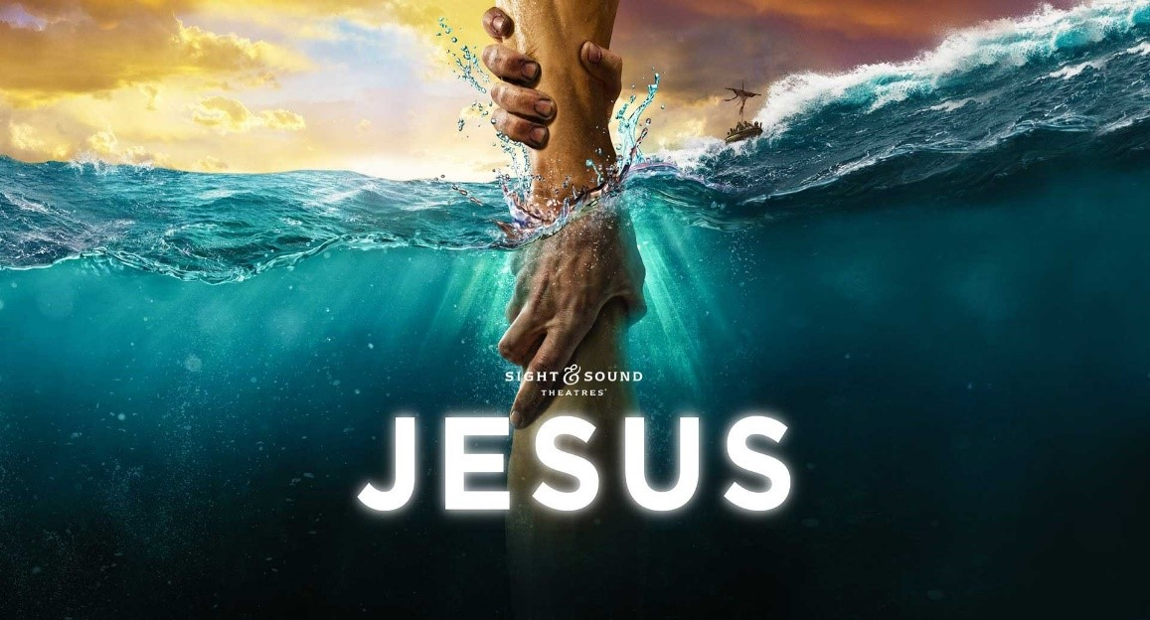
SIGHT & SOUND
Saint Rita’s is sponsoring a trip to Lancaster to see Sight & Sound. This year’s production is “JESUS”.

WEDNESDAY, OCT. 17, 2018
PRICE-$118.00/PP
$50 DEPOSIT(NON-REFUNDABLE)
REQUIRED WITH RESERVATION

INCLUDES: BUS, SHOW, & LUNCH AT SHADY MAPLE. BENEFITS ST. RITA CHURCH
FOR MORE INFO:
CALL MARY AT
570-676-3711

COMMUNITY WOMEN’S CLUB
presents a 5 day/4-night trip to
Myrtle Beach, SC
September 9-13, 2018
Package includes-4 nights accommodations at an oceanfront hotel, 4 breakfasts, 4 dinners including all-you-can-eat buffet at Captain George’s, Legends in Concert Show, visit to Broadway at the Beach (entertainment and shopping complex), guided tour of Charleston, SC, visit to Tanger Outlets, visit to Myrtle Beach’s waterfront Boardwalk and Promenade, baggage handling, hotel taxes & meal gratuities, services of Festive holiday hosts, and bus provided by Tiger Tours.
$100 per person (nonrefundable) deposit with reservation. Balance due by July 25, 2018.
Price: $749.00 per person, double occupancy.
Single supplement: $200 Additional. For more information and reservations contact: Mary at
570-676-3711.

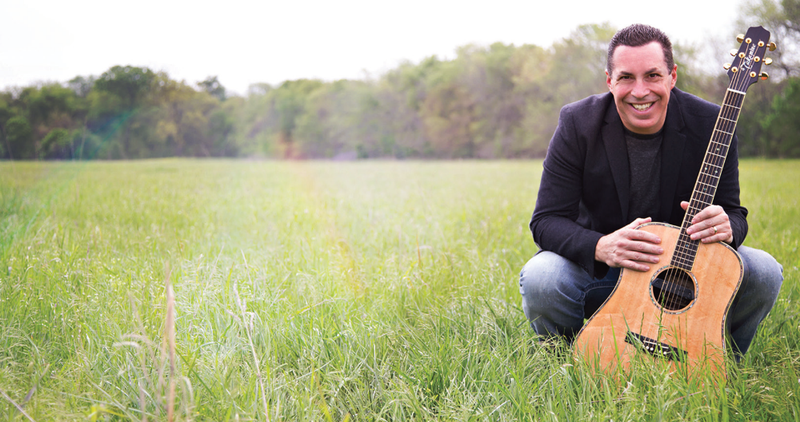

An evening of music and storytelling with Steve Angrisano.

Friday, June 15, 2018
7:00 PM
______________

St. Mark Catholic Church
1052 Bear Lake Rd
Thornhurst, PA 18424
Free-will offering will be taken up

For more information:
Anthony Butel
tbutel51@gmail.com
570-687-5390
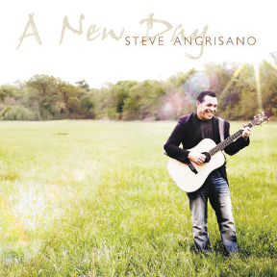
Steve Angrisano is undoubtedly one of the most effective and versatile ministry leaders in the Church today. Those who are young (and young of heart) embrace the passionate message of faith, hope and love woven throughout his music and storytelling. Always rooted in a spirit of humility and faithfulness. Steve has a keen intuition regarding the needs of any audience and engages them with his unique blend of humor, song, story and interaction. This makes him both a natural and popular choice for diverse parish, diocesan, national and world-wide events.



Steps to use online giving
- Go to our website: www.stritaspa.org
- Select the online Giving icon 

- First time users will need to create a new account: Login
User name
Password
Login
Forgot User ID or Password?

PRESS Create New Account

- Enter your profile information and select Enter Credentials

- Create a User ID, Password, Select that you are not a robot, and select Create Account

- Add a Bank account information Press Add Bank Account (we cannot yet take credit)

Create Payment
- Select a Fund to give to:
Example: Offertory (weekly collection)
Utilities

- Select a gift type: (One time, recurring, etc.), enter the amount, enter the start date, and select a frequency (weekly, monthly, etc.)
Ex: Gift type: ?
Recurring
What is the amount you’d like to give? $30
What date should this recurring gift start? 5/26/18
How often would you like these gifts to occur? (weekly, monthly, etc.)

- Review your gift summary and select submit

I would like to make a recurring Gift of $30.00 to Sunday Offertory. Please charge my Checking payment method Weekly starting on 5/26/18.

Submit Gift

